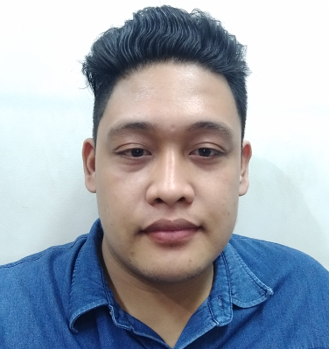

**Winnie A. Damayo**

B. Rodriguez, Espina Village

Mobile No.: 09208783268

Email: [winnie131212592@gmail.com](mailto:winnie131212592@gmail.com)

Web: https://.winex01.github.io

**http://winnie.16mb.com/**

**Experience**

**Gender: Female**

**Date of Birth: February 24, 1994**

**Age: 21**

**Marital Status: Single**

**Occupation: Fresh Graduate**

**Interests: Reading, creative writing, swimming, volleyball, travelling, watching documentary f**

**2017-06 – 2018-10-15 Web Developer / Programmer**

Treon HRExpress

Sabellano Street, Basak Pardo, Cebu City 6000 (SWU Old Campus)

**Responsibilities:**

* Fix Bugs
* Customer Supports
* Add features
* Migrate System to Latest Version
* Migrate Database
* Email Supports
* Backup Database(Postgres)
* Train new hired (before leaving)

**2016-04 - 2016-05** **IT Support & Technician**

OJT at International Pharmaceuticals, Inc. (IPI)

Kasambagan, Mabolo, Cebu City

**Responsibilities:**

* Format Computer and laptops
* Refill printer with ink and tuner
* Install applications
* Assist employee technical problems
* Train new intern

**TECHNICAL SKILLS**

**Gender: Female**

**Date of Birth: February 24, 1994**

**Age: 21**

**Marital Status: Single**

**Occupation: Fresh Graduate**

**Interests: Reading, creative writing, swimming, volleyball, travelling, watching documentary f**

Web: Html, JavaScript, Bootstrap, PHP, MySQL, PDO, AJAX jQuery, PostgreSql

Familiar with the Basics (at School): C#, C, C++, JAVA, Arduino Programming, MIT Inventor App

Others: MVC pattern, Object Oriented Programming, CodeIgniter, Laravel, Ubuntu Shell Scripts, Laragon, Git

**CERTIFICATE AND AWARDS RECEIVED**

**Date of Birth: February 24, 1994**

**Age: 21**

**Marital Status: Single**

**Occupation: Fresh Graduate**

**Interests: Reading, creative writing, swimming, volleyball, travelling, watching documentary f**

**ACER IT EXCELLENCE AWARD**

March 24, 2017

Palompon, Leyte

**Skills Olympic for Programming Winner**

February 18, 2016

Palompon Institute of Technology (PIT)

**PIT Science Fair Consolation Prize**

February 2016

Palompon Institute of Technology

**Microsoft Office Training Program**

**TRAININGS AND SEMINARS ATTENDED**

**Date of Birth: February 24, 1994**

**Age: 21**

**Marital Status: Single**

**Occupation: Fresh Graduate**

**Interests: Reading, creative writing, swimming, volleyball, travelling, watching documentary f**

January 6 2008

STI

Ormoc City, Leyte

**Public Speaking & Confidence Building Program**

May 16, 2009

Martinelli Speech Center

Ormoc City, Leyte

**Ethics in the Workplace (PIT CHIC)**

February 9, 2017

Palompon Institute of Technology

Palompon, Leyte

**EDUCATIONAL BACKGROUND**

**Gender: Female**

**Date of Birth: February 24, 1994**

**Age: 21**

**Marital Status: Single**

**Occupation: Fresh Graduate**

**Interests: Reading, creative writing, swimming, volleyball, travelling, watching documentary f**

**Bachelor of Science in Information Technology (2017)**

Palompon Institute of Technology (PIT)

Palompon, Leyte

**Projects**

My Repository:

* www.github.com/winex01
* [www.sourcecodester.com/user/129831/track](http://www.sourcecodester.com/user/129831/track)

**Reference**

* Vlad Redula(Treon Programmer) - 09173196878
* Bryan Arnel Geonzon(Treon Programmer) - 09350540457